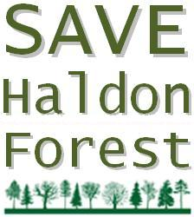
Save Haldon Forest ... Save All Our Forests

Date:
My address:

________________________MP
House of Commons
London
SW1A 1AA

Dear _______________________

I wish to register my opposition to the government’s proposals to sell off the public forests in England. These proposals represent a great loss of amenity for the millions of British people who visit the national forest estate every week and wish to continue their enjoyment of it.

Studies show that being close to green space encourages exercise, and therefore helps to fight obesity. Lack of physical activity costs the economy in England alone over £8 billion a year. Far more than could possibly be raised by the forest sell off.

The public forests only cost us £15 million (just 30p per taxpayer per year). This is excellent value for money. The forests are a natural treasure store that should remain in public ownership rather than become privatised, which would mean that we would lose the forests forever.

Yours sincerely

Signed: __________________________
My address:

Date:

_______________________________MP
House of Commons
London
SW1A 1AA

Dear _____________________________

I object most strongly to the government’s proposals to sell off the Forestry Commission forests in England. These proposals are a great loss of amenity for the millions of British people who visit the national forest estate every week and wish to continue their enjoyment of it.

Forests are net absorbers of carbon dioxide while they are growing, but then release the gas when they are cut down. The Public Bodies Bill gives no guarantee that the forests will not be sold for logging.

Woodland also performs a variety of valuable natural "services" to the ecosystem, including carbon sequestration, protecting soils from erosion, reducing flooding, providing shelter, shade, cooling and windbreaks, and conserving biodiversity.

Yours sincerely

Signed: __________________________

